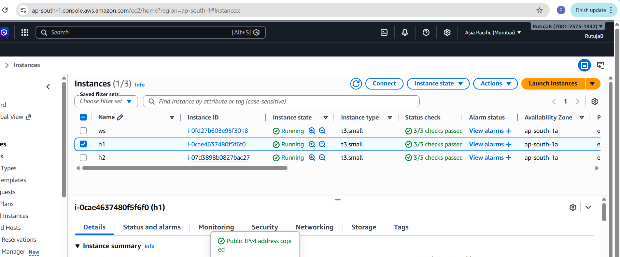
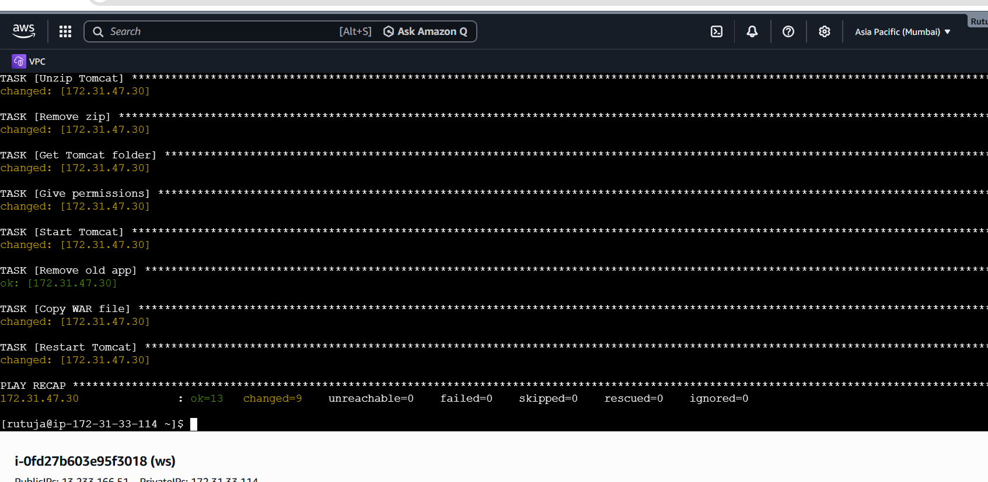
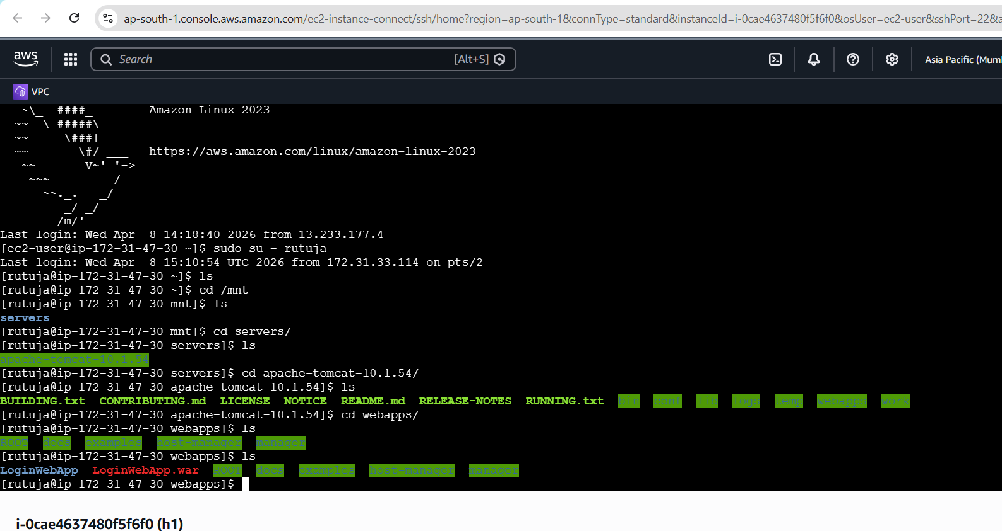
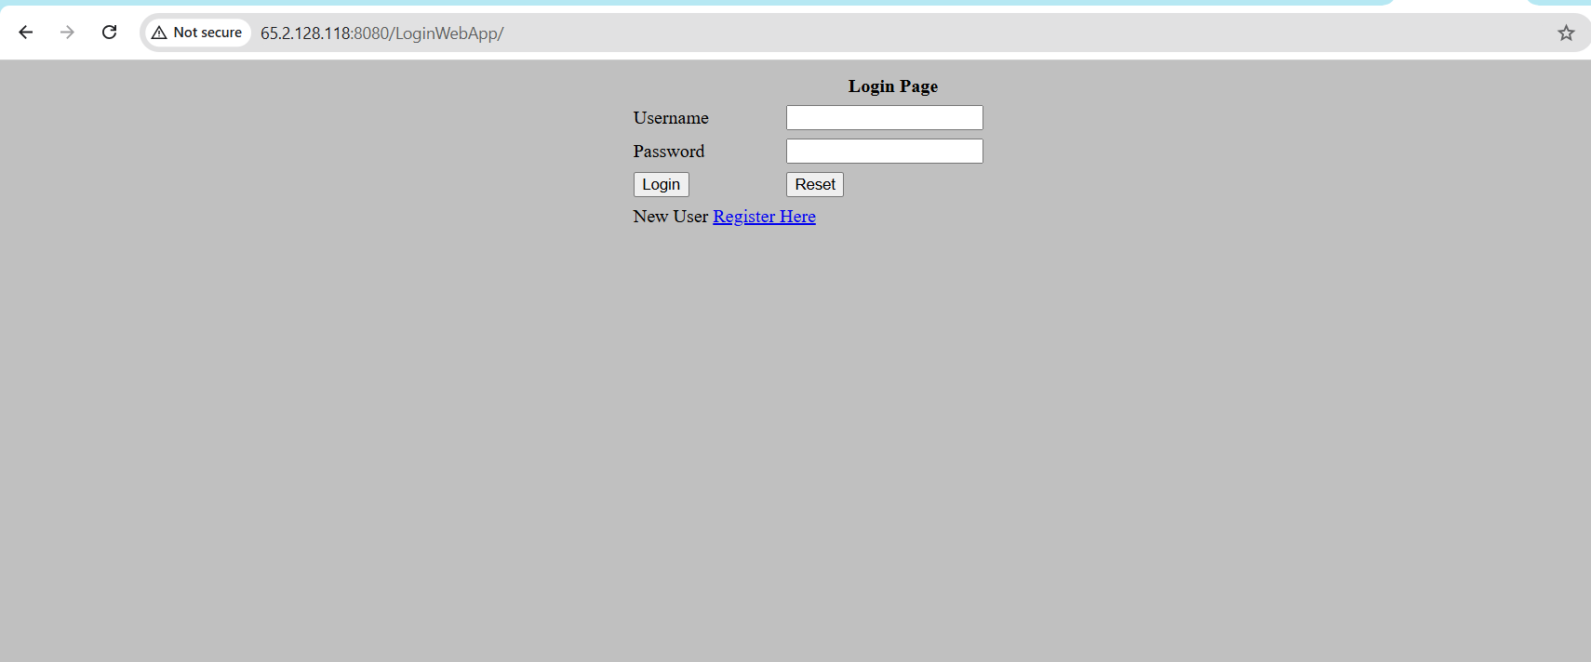
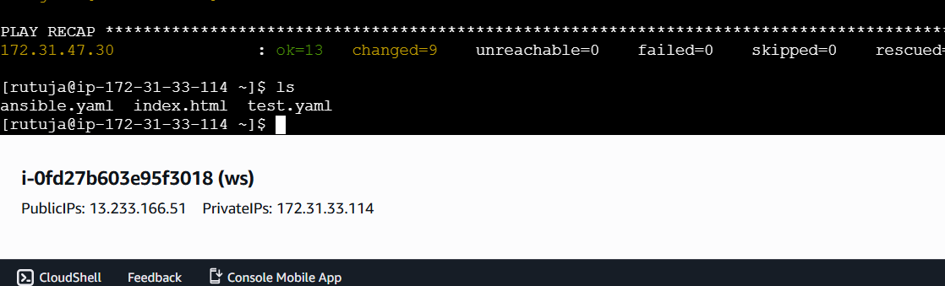
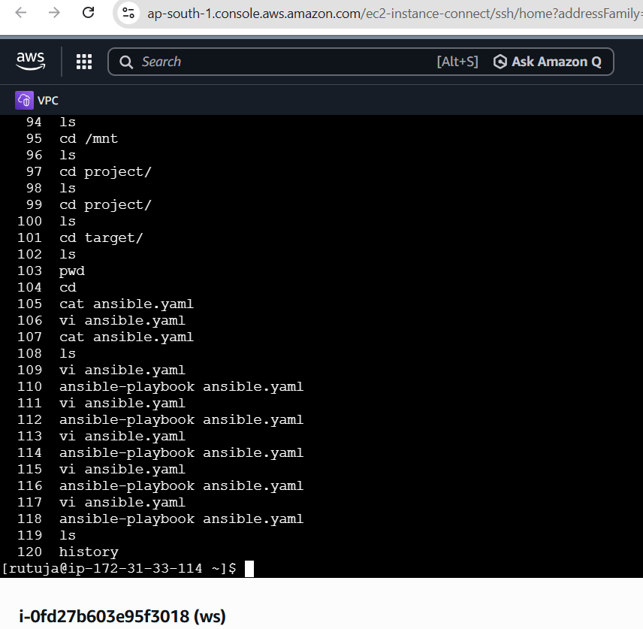
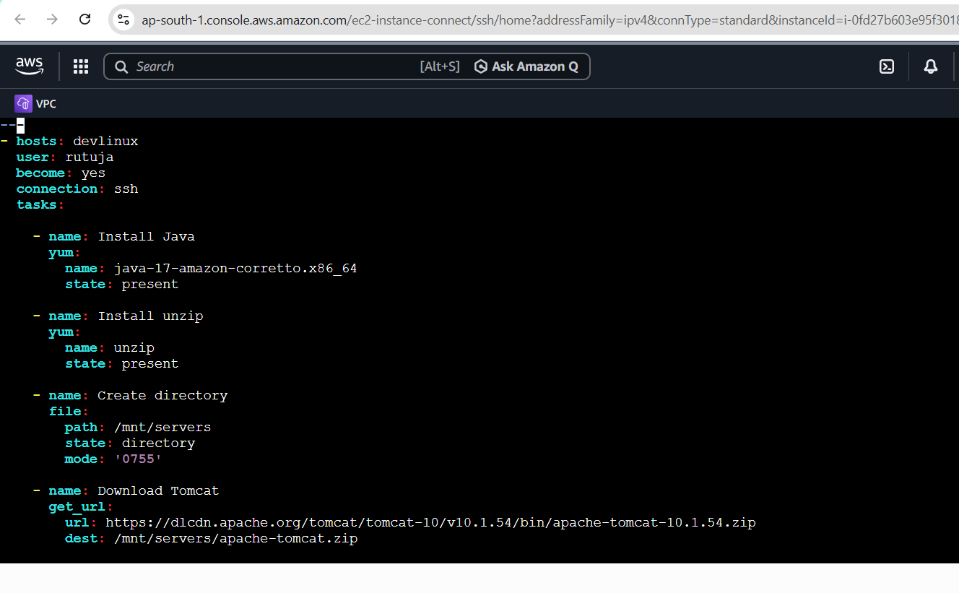
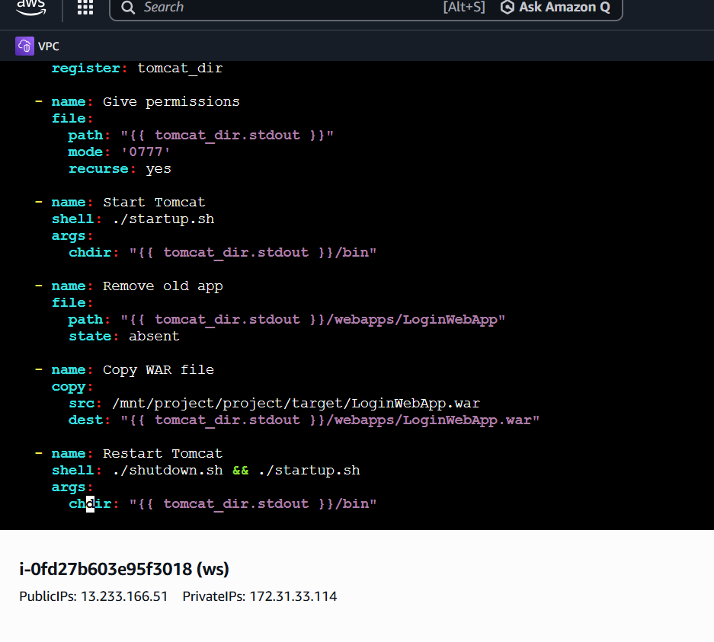
---
- hosts: devlinux
user: rutuja
become: yes
connection: ssh
tasks:

- name: Install Java
yum:
name: java-17-amazon-corretto.x86_64
state: present

- name: Install unzip
yum:
name: unzip
state: present

- name: Create directory
file:
path: /mnt/servers
state: directory
mode: '0755'

- name: Download Tomcat
get_url:
url: https://dlcdn.apache.org/tomcat/tomcat-10/v10.1.54/bin/apache-tomcat-10.1.54.zip
dest: /mnt/servers/apache-tomcat.zip

- name: Unzip Tomcat
unarchive:
src: /mnt/servers/apache-tomcat.zip
dest: /mnt/servers/
remote_src: yes

- name: Remove zip
file:
path: /mnt/servers/apache-tomcat.zip
state: absent

- name: Get Tomcat folder
shell: ls -d /mnt/servers/apache-tomcat-*
register: tomcat_dir

- name: Give permissions
file:
path: "{{ tomcat_dir.stdout }}"
mode: '0777'
recurse: yes

- name: Start Tomcat
shell: ./startup.sh
args:
chdir: "{{ tomcat_dir.stdout }}/bin"

- name: Remove old app
file:
path: "{{ tomcat_dir.stdout }}/webapps/LoginWebApp"
state: absent

- name: Copy WAR file
copy:
src: /mnt/project/project/target/LoginWebApp.war
dest: "{{ tomcat_dir.stdout }}/webapps/LoginWebApp.war"

- name: Restart Tomcat
shell: ./shutdown.sh && ./startup.sh
args:
chdir: "{{ tomcat_dir.stdout }}/bin"
